Physical Education
December 2013

Happy Festivus, for all you Seinfeld fans out there. A great time of year I am a fan of the Holidays as long as I don’t have to go to a mall, or Walmart. Here at the school we are wrapping up an enjoyable first semester. In P.E. we have gotten a lot of things in and I am excited about the next semester and what it holds.
To wrap up the first semester we just finished learning, practicing, and playing indoor soccer. It is a sport that a lot of Clarkson kids have not been exposed to. Some picked up the skills very well, the things that I hope they got out of it are teamwork, spacing, and awareness. Like any sport there are lessons to be learned that can help us in everyday life. We did have a pretty epic battle in P.E. 1 with a 5 game series, in which I did include a picture of the championship team.
As we look forward into January I am excited to do a first time unit with our P.E.1 class. This unit is Archery. We were able to get a grant last year, and with some help from Mr. Lemburg it enabled us to get some high quality indoor archery equipment. I am really looking forward to this. We also have some team handball, as well as badminton, and pickleball It is going to be fun. In the Elementary we will kick off the New Year with some Jump Rope and Hoops foe Heart. If our elementary students approach you PLEASE be open to donating a little bit to try and help a good cause. I realize it is post Christmas but it really is an important cause, we even have a current student Christopher Konicek, who had to undergo a heart procedure last year. He is now doing well, but it is a reminder that we must take care of our most vital organ the heart.
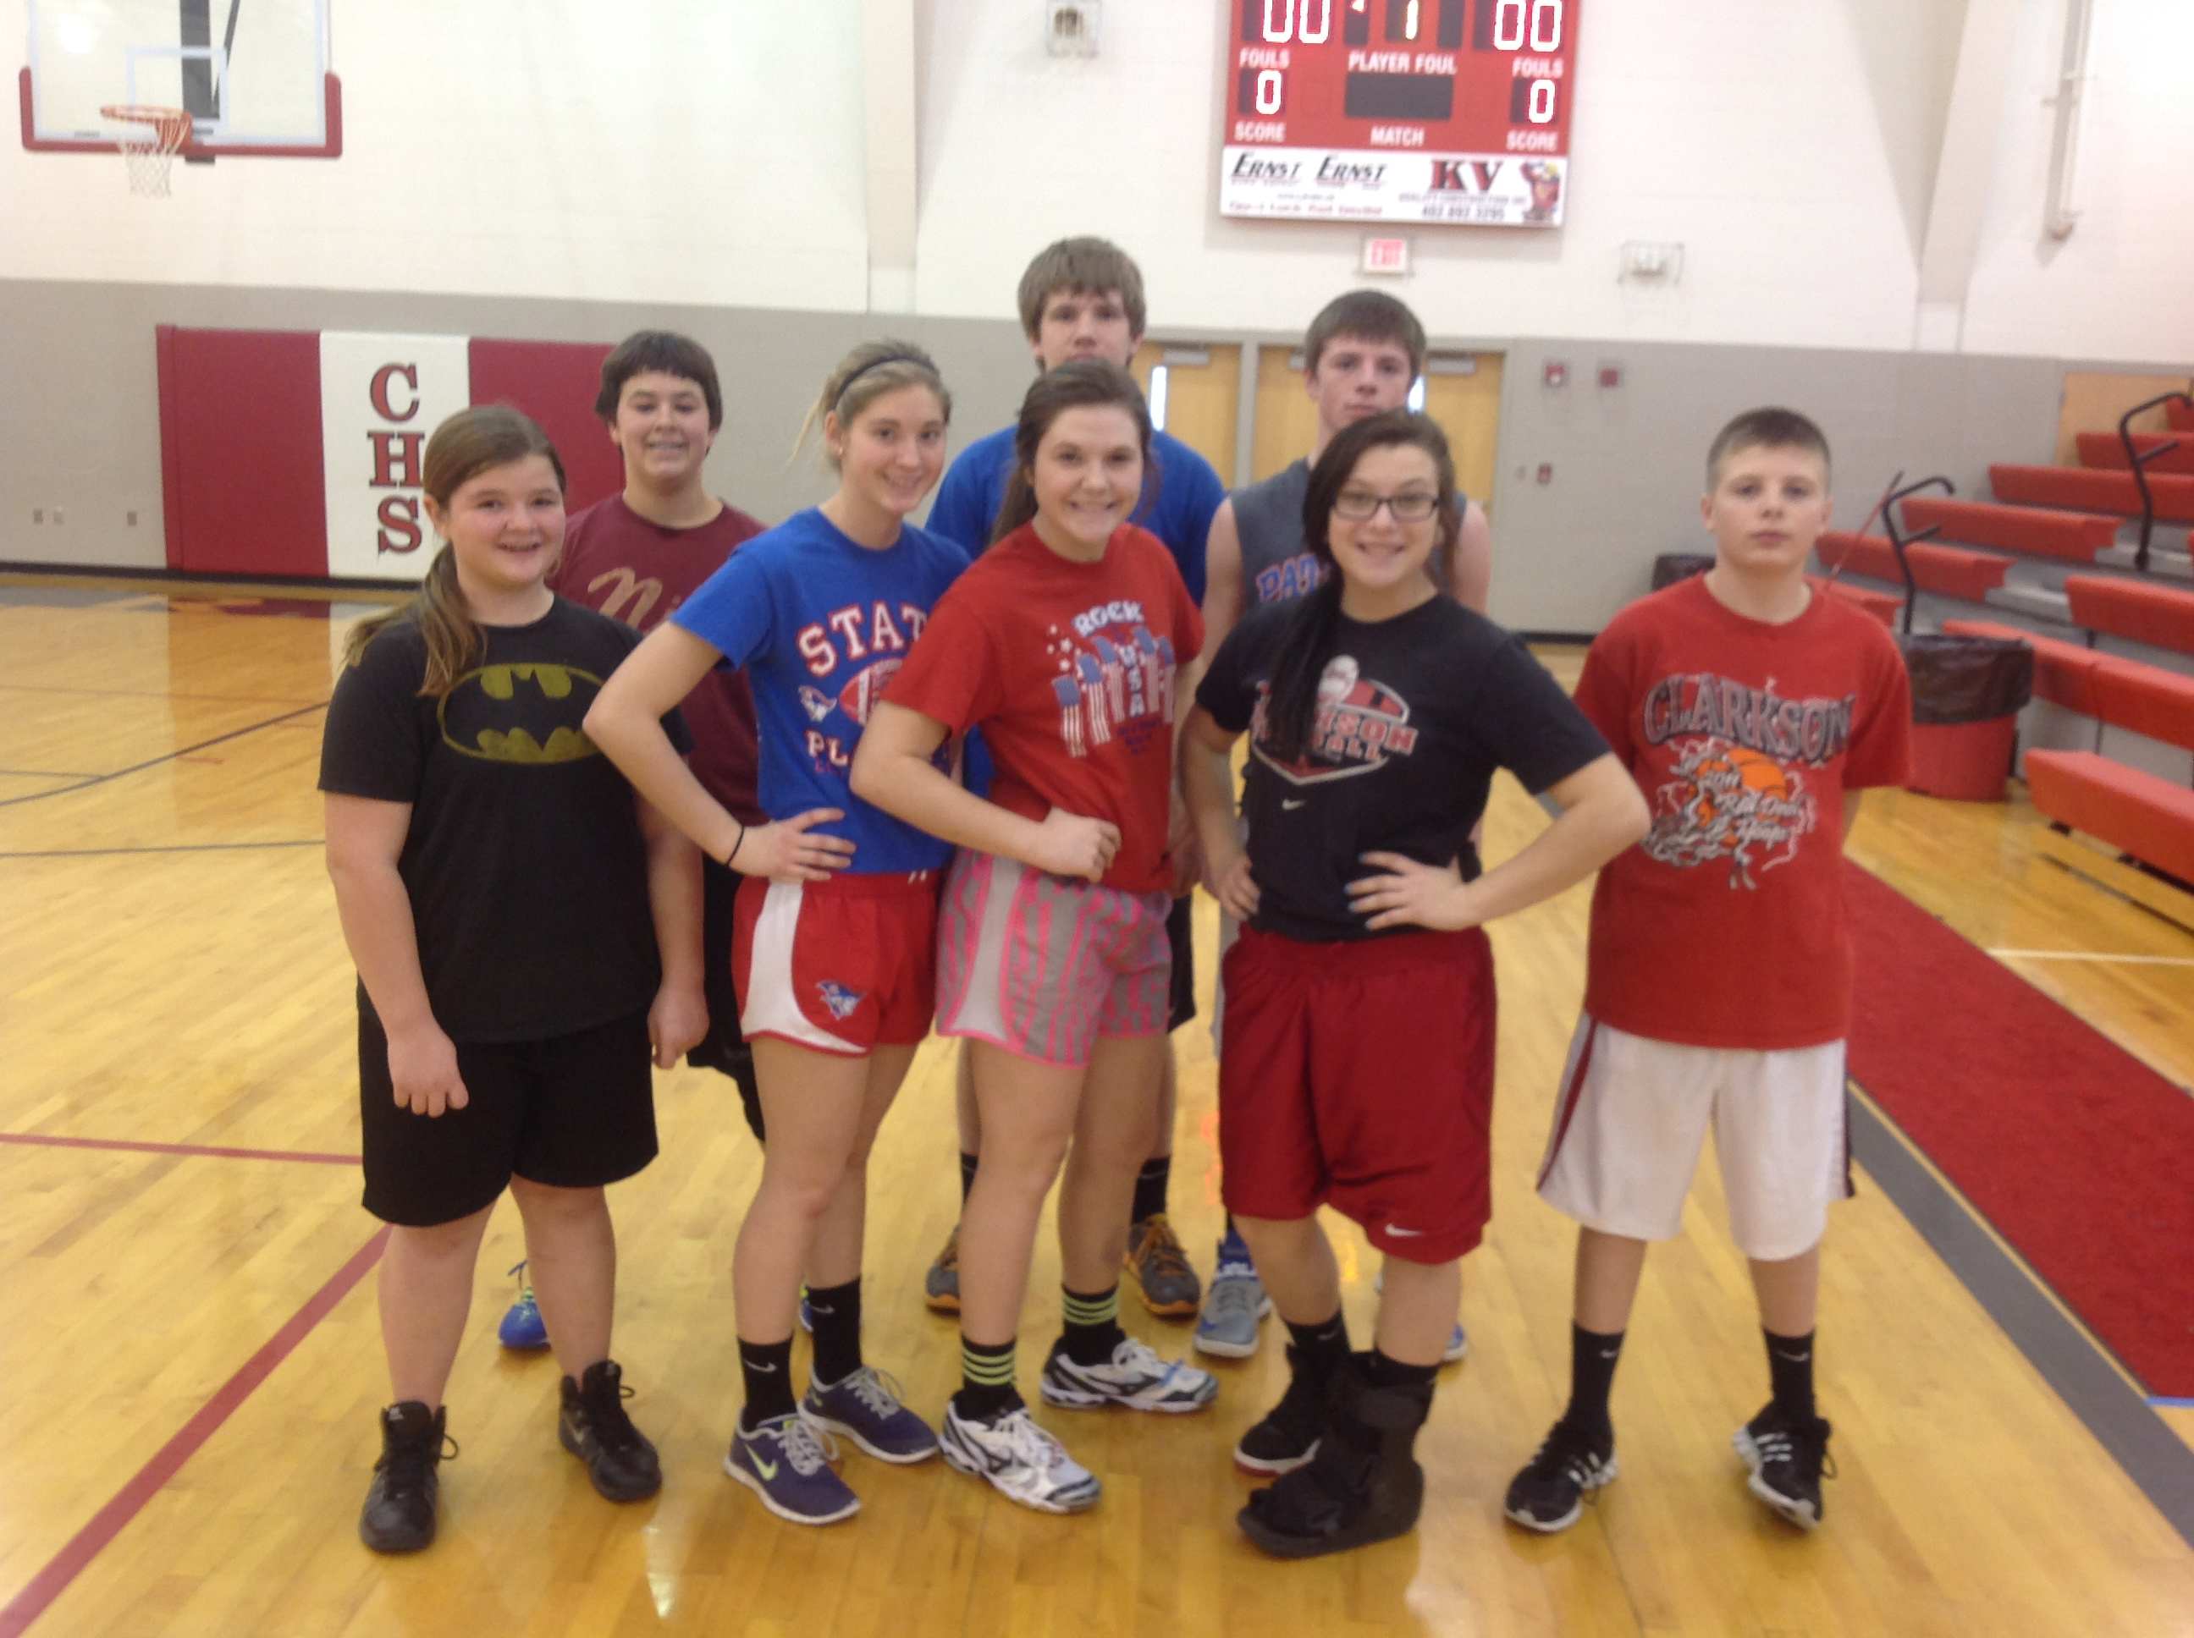
One more and I am out of here. I would just like to say thank you, to everyone that supports our school and sports teams. We have a great community here at the school and a great relationship with Leigh as well. The power of sports and/or being part of a team is very important. It can be a sports team or your family or work can be a team, but either way we cannot do it alone. So embrace the Teamlife because when you have a team working for one goal good things will happen. So may you and your Team have a great 2014. GO PATS!

